**Introduction and project description:**

The main goal of this project is to analyze the different options Barcelona's districts offer to a tourist and which is the most suitable to stay.

Nowadays it is possible to organize a trip by yourself by using the internet. But when you decide to visit a new place it can be very chaotic to organize your trip. It's a new city you have never been before to and deciding where to stay can be very tricky.

If you make the decision based only on the accommodation's price can lead to a very poor choice of a neighborhood that is too far from everything. That can end to a loss of time and money in the end.

Analyzing the different options for:

* Nightlife
* Food options
* Places of interest
* Transportation
* Accommodation

can definitely help to make a better decision.

**Data sources used:**

Two sources of data will be used to solve the problem described above.

The first is a wikipedia page with the Barcelona's districts and neighbourhoods:

<https://en.wikipedia.org/wiki/Districts_of_Barcelona>

The second is the Foursquare database. For each Barcelona district we will find the top 100 venues and use them to analyze the different options each district offers.

**Methodology used to solve the problem:**

Before we get the data and start exploring it, all the needed dependencies are installed and imported:

* import pandas: pandas is a fast, powerful, flexible and easy to use open source data analysis and manipulation tool built on top of the Python programming language (<https://pandas.pydata.org/>).
* import urllib.request: urllib.request module defines functions and classes which help in opening URLs (mostly HTTP) in a complex world — basic and digest authentication, redirections, cookies and more (<https://docs.python.org/3/library/urllib.request.html>).
* Install and import BeautifulSoup: Beautiful Soup is a library that makes it easy to scrape information from web pages. It sits atop an HTML or XML parser, providing Pythonic idioms for iterating, searching, and modifying the parse tree (<https://pypi.org/project/beautifulsoup4/>).
* Install and import geocoder: Simple and consistent geocoding library written in Python (<https://pypi.org/project/geocoder/>).
* Install and import folium: folium builds on the data wrangling strengths of the Python ecosystem and the mapping strengths of the Leaflet.js library. Manipulate your data in Python, then visualize it in a Leaflet map via folium (<https://pypi.org/project/folium/>).
* import matplotlib: Matplotlib is a comprehensive library for creating static, animated, and interactive visualizations in Python (<https://matplotlib.org/>).
* Install and import Nominatim: Nominatim uses OpenStreetMap data to find locations on Earth by name and address (geocoding). It can also do the reverse, find an address for any location on the planet (<https://nominatim.org/>).

The next step is to obtain the list with Barcelona's districts (barrios) from Wikipedia page:

<https://en.wikipedia.org/wiki/Districts_of_Barcelona>

The following dataframe is produced by using the pandas library:

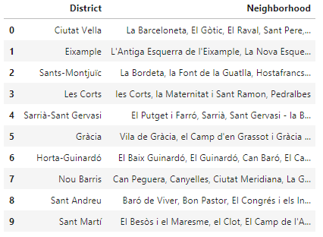

Then each district’s location is added to the dataframe by using geocoder:

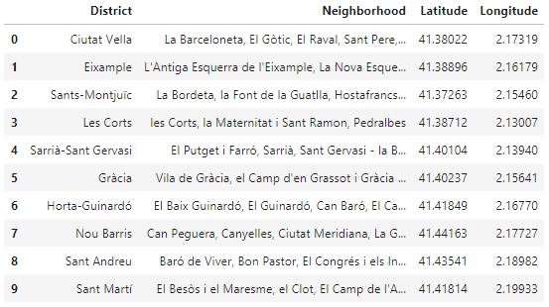

Then folium is used to visualize the different districts on the Barcelona’s map:

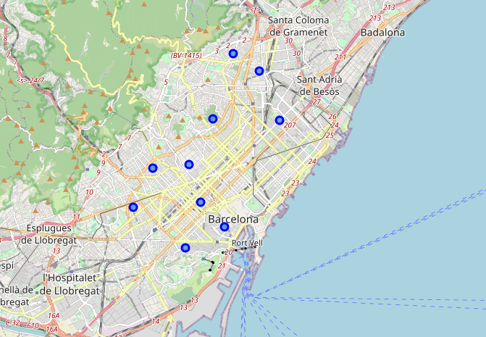

After that Foursquare’s credentials are imported and explore function is used to get the top 100 nearby venues for each district.

The following dataset is created:

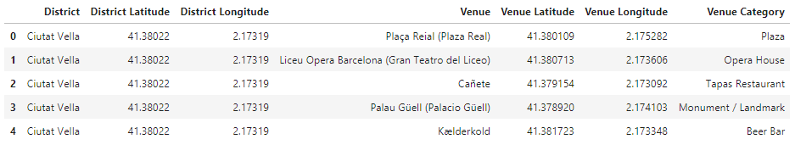

A dictionary is created to re-categorize the venues to the following categories:

* Sight-seeing,
* Culture,
* Restaurant,
* Nightlife,
* Groceries,
* Coffee,
* Hotel,
* Misc,
* Dessert,
* Sports,
* Shop,
* Transportation

The following dataframe is created with one row per district and a column per venue category. For each district we have the count per venue category:

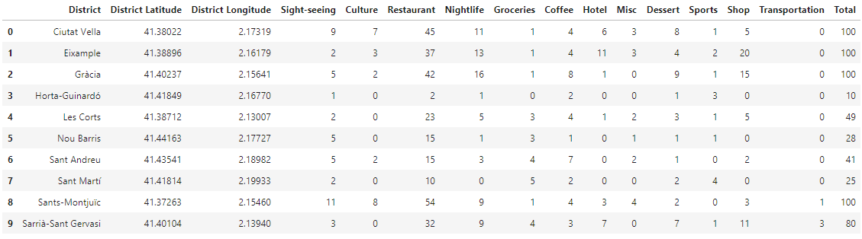

Matplotlib is used to inspect the character of each district:

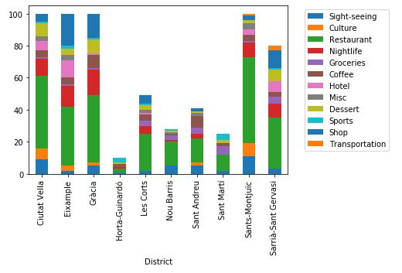

Finally two more plots are created to inspect the different entertainment and cultural options of each district.

**Results:**

At the following dataframe the 10 Barcelona’s districts and their neighborhoods are shown:



At the following map those districts are shown:



After the re-categorization explained in the methodology section the following dataframe is produced:



Let’s visualize the character of each district:



Let’s visualize the entertainment options of each district:

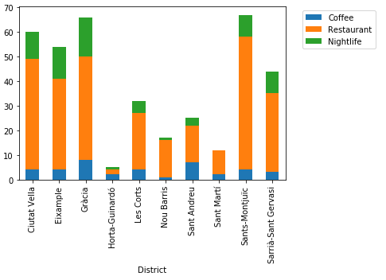

And the cultural options of each district:

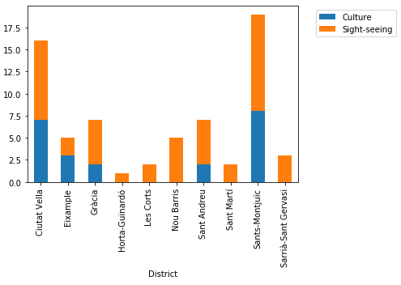

**Discussion:**

As it is shown on the entertainment plot Ciutat Vella, Sant Marti and Sants-Montjuic offer more nightlife options. Sant Marti offers the most restaurant and coffee options but Ciutat Vella offers more nightlife options. Sants-Montjuic and Ciutat Vella offers the most options for culture and sight-seeing.

Because Ciutat Vella offers many options both for culture and fun it should be more suitable for the average tourist.

**Conclusion:**

This is a first approach on the problem, there is space for more detailed analysis. Each person is different so that could be something to include. For example a family with small children would prefer a quieter district and may not be interested in its nightlife. A young traveler may be more interested in a district’s nightlife. An older couple may prefer a district that offers many cultural options.